**HOTEL RENTAL MANAGEMENT**

**Phase 02**

**Screen Shots for the project**

**Login Credentials Table:**

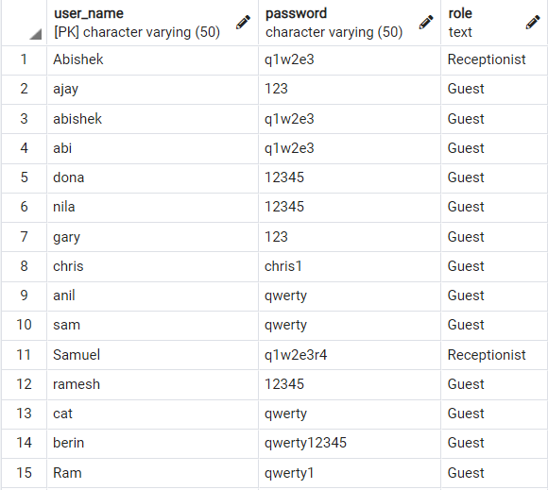

**Guest Info Table:**

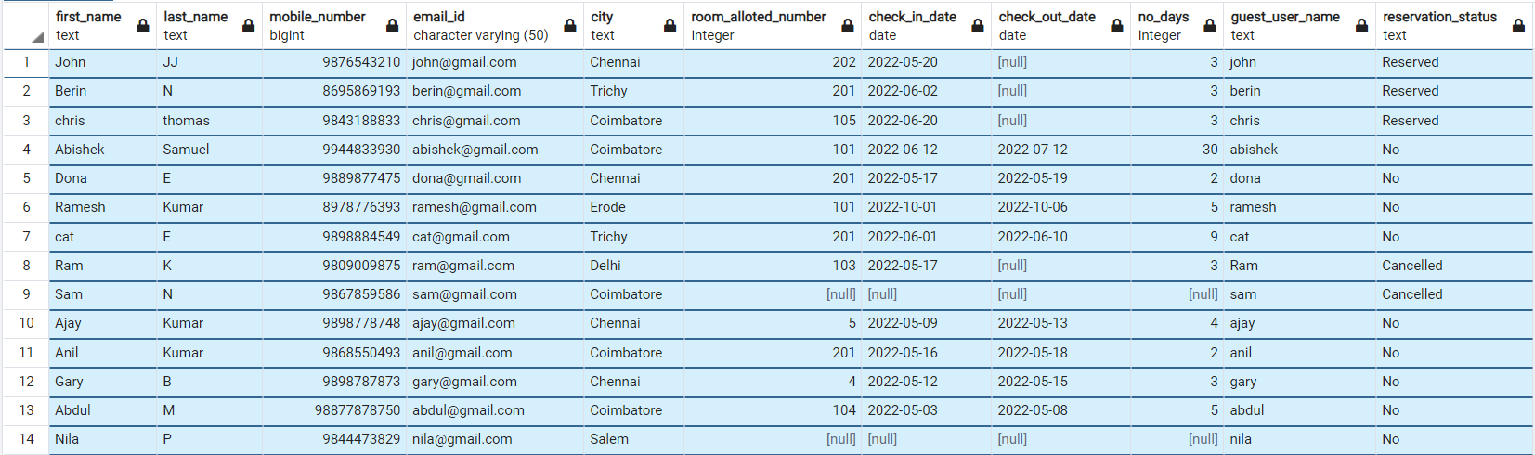

**Guest Details When Logged-In:**

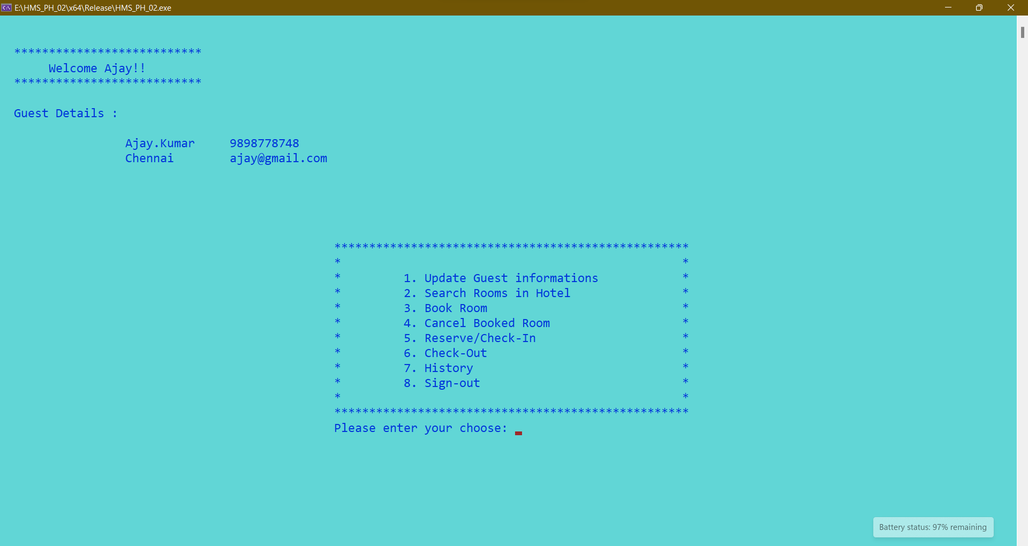

**Room Booking Screen:**

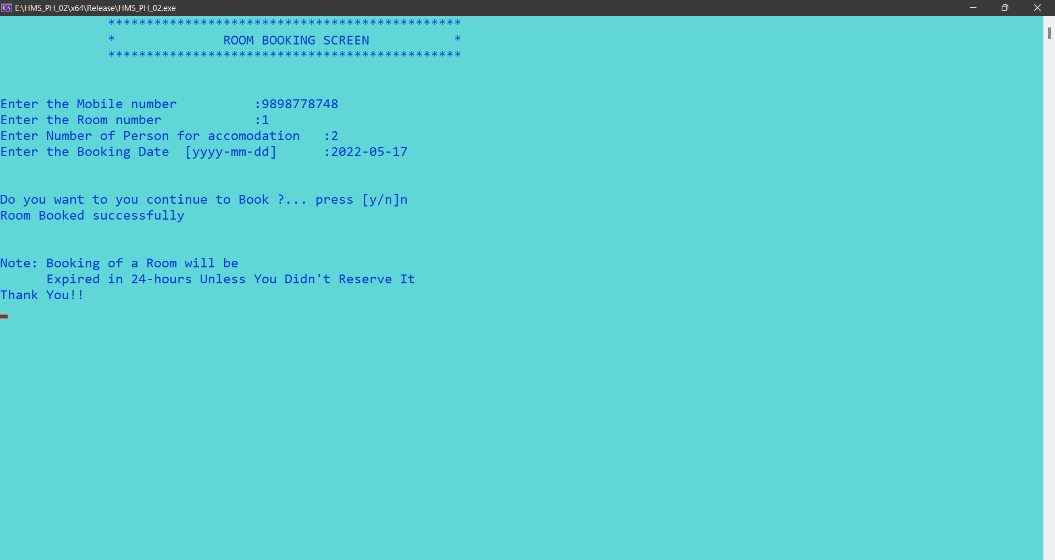

* The booked room will be canncelled or Expired in 24hrs unless the guest reservs it.

**In Guest-Info Table:**



**In Booking-Info Table:**



**In Hotel-Rooms-Info Table:**



**On Expiry of Booked Room:**

The Guest gets a notification when the Booking of the room is Expired.

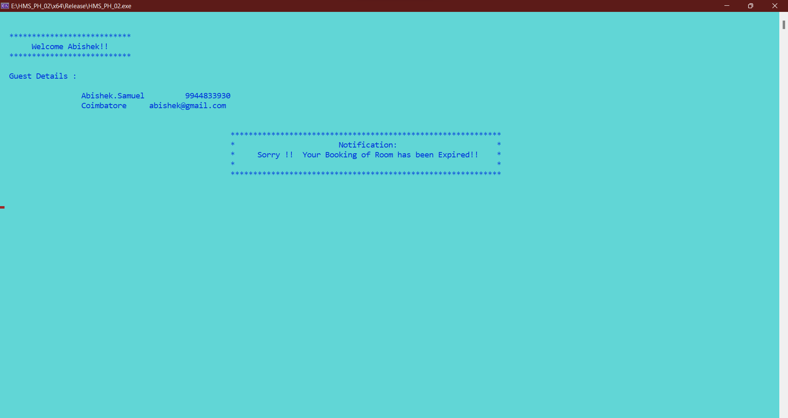

**In Booking Info Table:**



After the Cancellation of the Booked Room, it will be Available for Rebooking.

**Guest Room History:**

